# Top, Middle, and Bottom Thirds - Average Medals

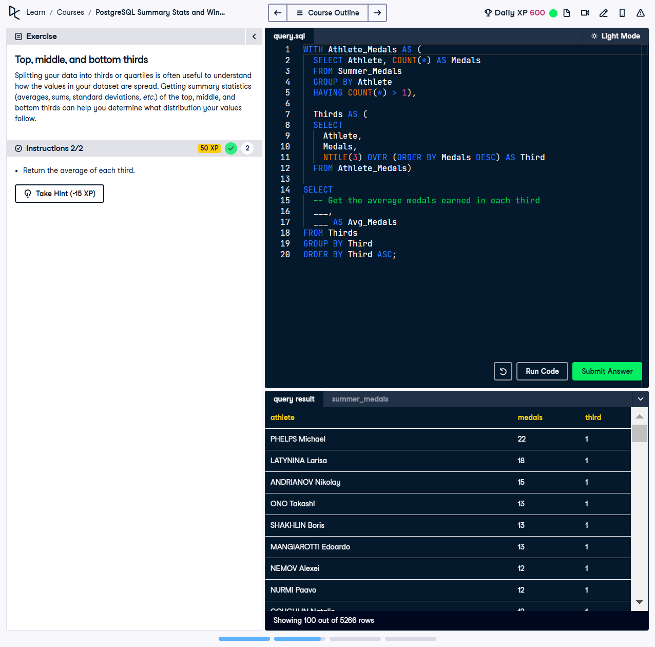

Splitting your data into thirds or quartiles is useful to understand how the values in your dataset are spread. Getting summary statistics (averages, sums, standard deviations, etc.) of the top, middle, and bottom thirds can help you determine what distribution your values follow.

This exercise involves using two Common Table Expressions (CTEs) to divide athletes into thirds based on their medal counts and calculate the average medals earned by athletes in each group. This analysis provides insights into performance distribution.

## Correct Answer

WITH Athlete_Medals AS (  
 SELECT  
 Athlete,  
 COUNT(*) AS Medals  
 FROM Summer_Medals  
 GROUP BY Athlete  
 HAVING COUNT(*) > 1  
),  
Thirds AS (  
 SELECT  
 Athlete,  
 Medals,  
 NTILE(3) OVER (ORDER BY Medals DESC) AS Third  
 FROM Athlete_Medals  
)  
SELECT  
 Third,  
 AVG(Medals) AS Avg_Medals  
FROM Thirds  
GROUP BY Third  
ORDER BY Third ASC;

Explanation of the query:

1. `WITH Athlete_Medals AS (...)`: Calculates the total medals won by each athlete, filtering those with more than one medal.

2. `WITH Thirds AS (...)`: Divides athletes into three equal groups using `NTILE(3)`, ordered by their total medal count in descending order.

3. `SELECT Third, AVG(Medals) AS Avg_Medals`: Computes the average medals earned by athletes in each third, grouped by `Third`.

4. `ORDER BY Third ASC`: Ensures the results are presented in ascending order of thirds for clarity.